Login username is admin and password is password for test purposes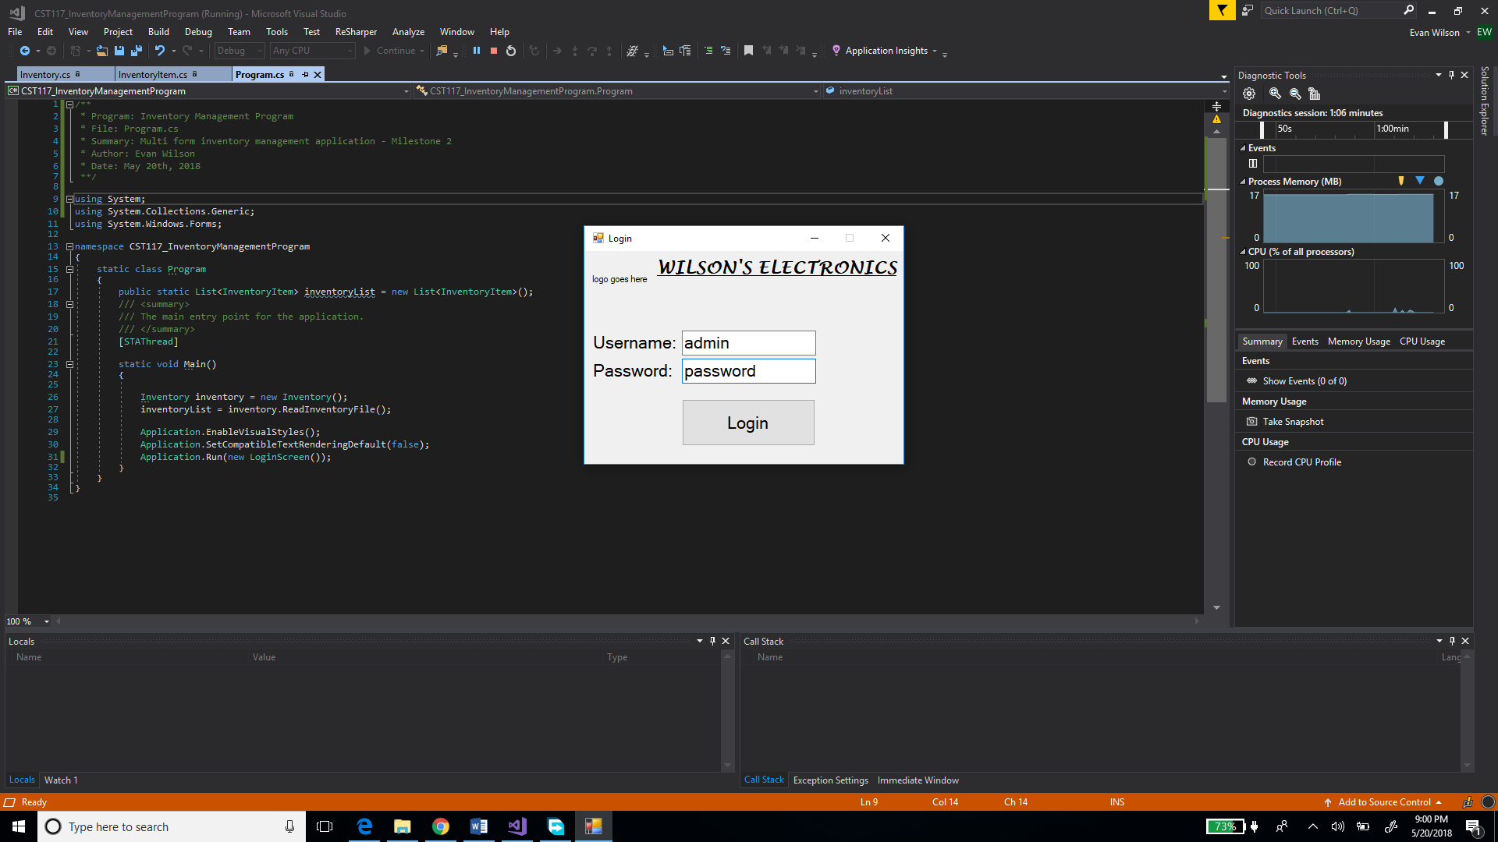

Program.cs has driver that reads inventory into a List<> to view on data grid

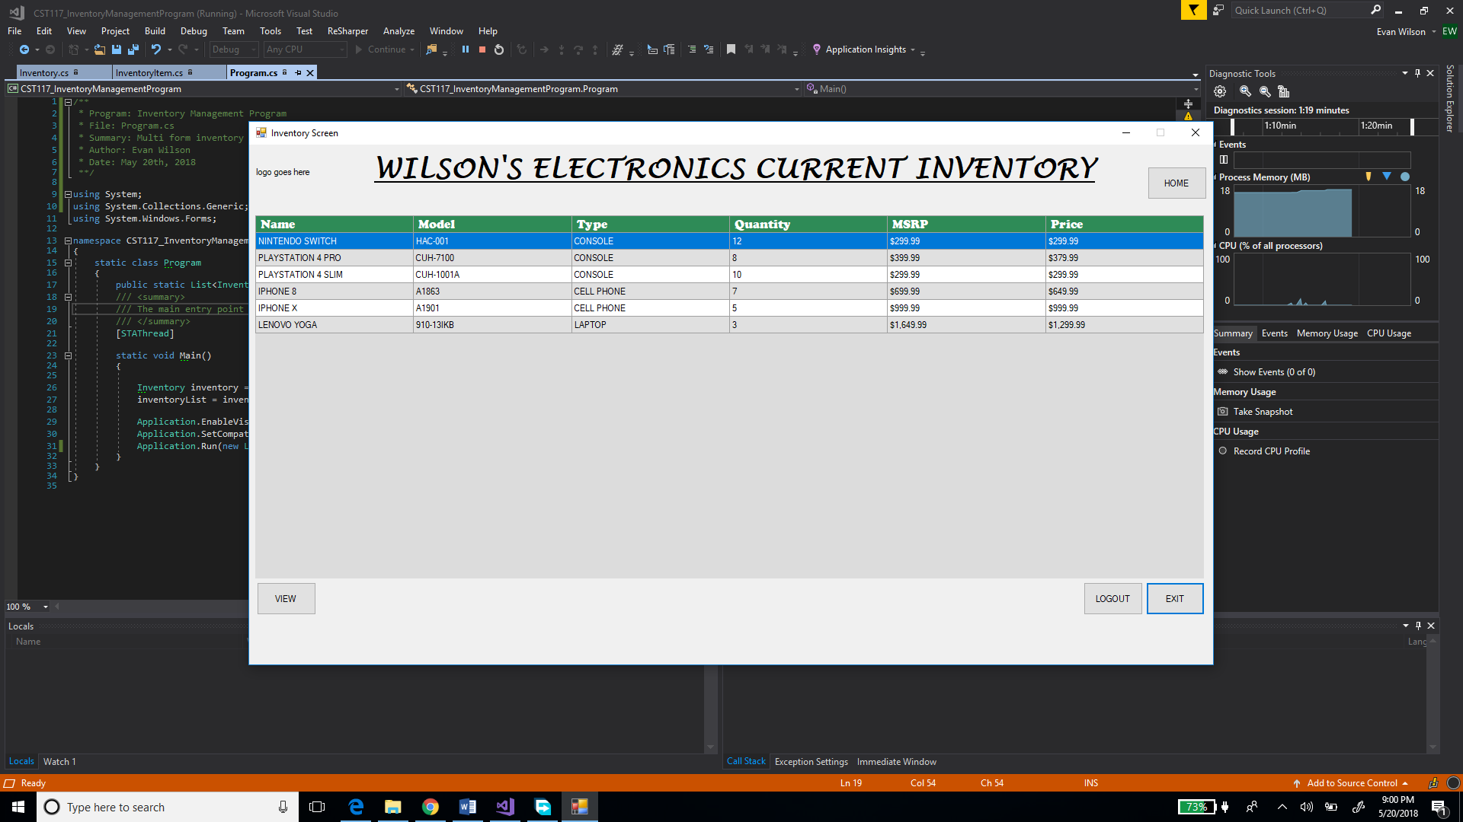

CSV file that inventory is read from

